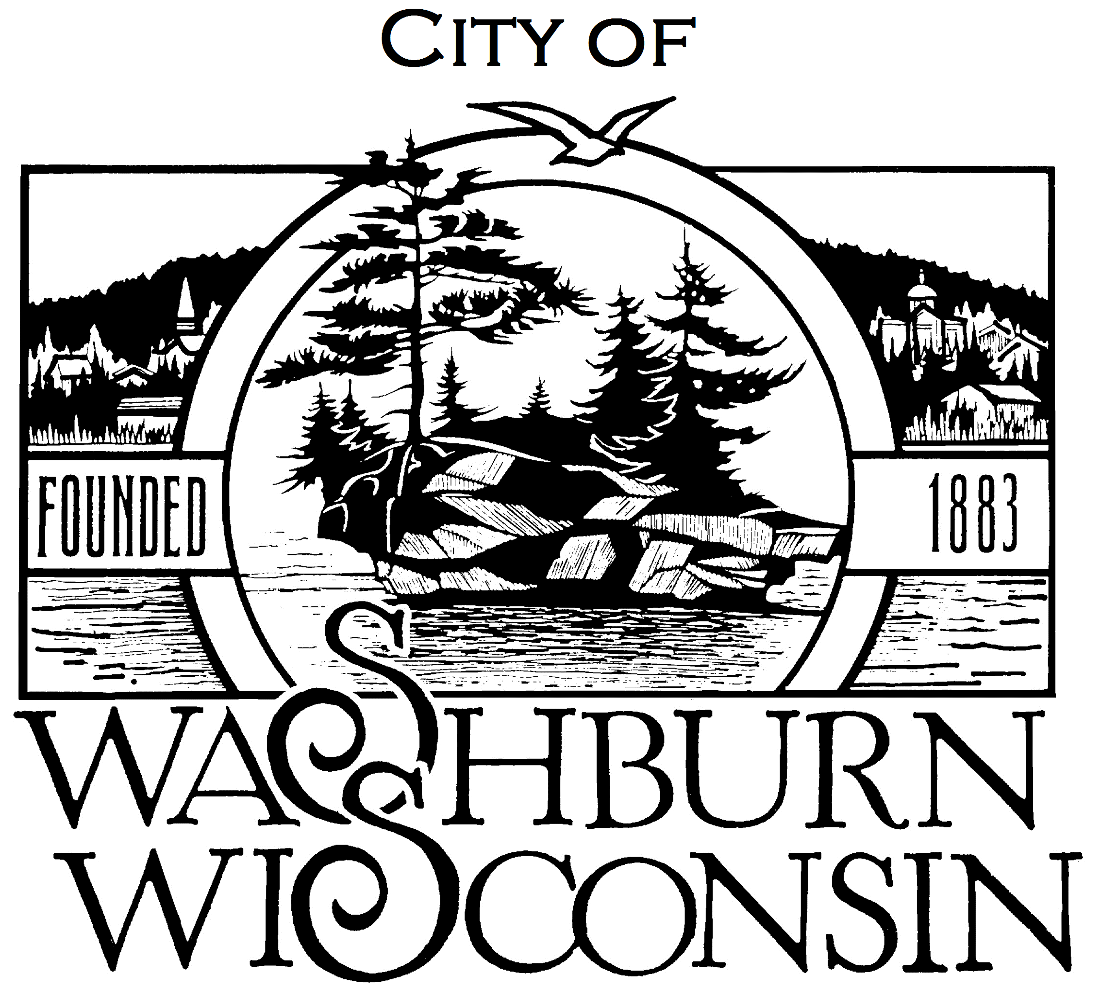

CITY OF WASHBURN
119 Washington Avenue 715-373-6160
P.O. Box 638 715-373-6161
Washburn, WI 54891 FAX 715-373-6148

NOTICE OF PARKS COMMITTEE MEETING

DATE: October 22, 2018

TIME: 4:30pm

PLACE: Will begin at Washburn City Hall at 4:30 pm. The Committee may go onsite to the boat launch at West End Park.

Agenda:

- Call to Order
- Approval of the September 18, 2018 Meeting Minutes
- Discussion and Recommendation on North Coast Community Sailing Operations and Location
- Discussion and Action on Location of Outside Exercise Equipment
- Discussion and Recommendation on Possible Dog Park and Possible Locations
- Future Topics
- Adjournment

It is possible that members of, and possibly a quorum of, members of other governmental bodies of the City of Washburn in attendance at the above meeting. No action will be taken by any governmental body other than the Parks Committee.

